**PROJECT**

**IE 6700 Data Management for Analytics**

**TITLE**

Cricket Auction Player Performance Database Management System

**GROUP NUMBER - 6**

Yash Bhadreshwara

Sparsh Marwah

**PROBLEM STATEMENT**

In the world of professional cricket, team owners attend auctions to pick skilled players who can help their teams win. Choosing the right players during these auctions is super important because it directly affects how well the team does in games and competitions. To make smart choices, team owners and managers need to look at how well a player has done in the past, what role they play, and how they can help the team win. The main issue we are tackling is creating a strong system that uses data to help team owners pick the best players during these cricket auctions. We want this system to help team owners and managers make smart decisions that will make their cricket teams better and more competitive.

**ENTITIES & THEIR FUNCTIONALITIES**

1. **Player** - It stores information about players such as their ID, Name, Stance, Age, Batting Order, Bowler Type, Wicketkeeper and their roles as a subclass i.e Batsmen, Bowler, All-Rounder.
2. **Team** - It gives us information about the team which is Name, Owner, Home City & Home Ground.
3. **Match** - It tells us about the match details such as Venue, Match No, Date, Result, Winning and Losing Team.
4. **Performance** - It shows us the performance details about the player such as Runs Scored, Wickets Taken, No of boundaries and Man of the Match.
5. **Nationality** - It tells us about the nationality type of the player (National or Overseas).
6. **Auction** - It stores information about the auction details of the player which are Auction ID, Previous Year Price and Base Price.
7. **Coach** - It gives us information about the type of coach, Coach Name and name of the team whom they are coaching to.

**UPDATED EER DIAGRAM**

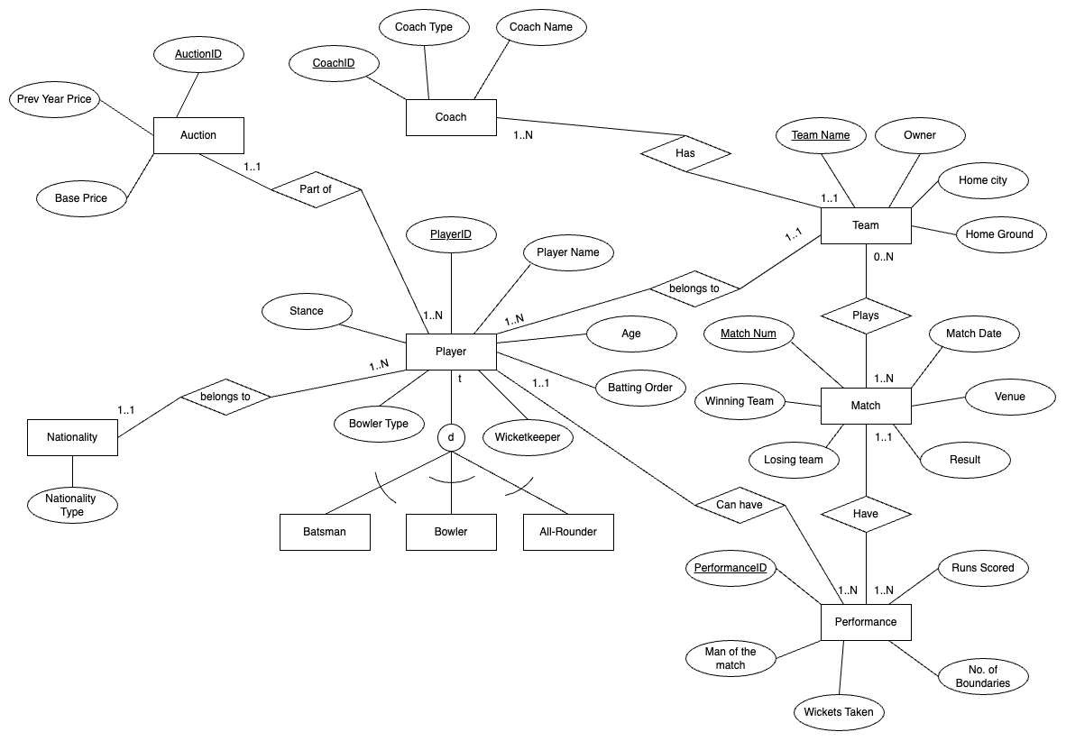

**REFERENCE DATA**

**Primary Keys:** Player ID, Team Name, Match ID, Performance ID, Auction ID, Coach ID.

**Foreign Keys:** Player ID, Winning Team, Losing Team, Match ID.

**TRANSACTIONAL DATA**

Previous Year Price, Base Price

**UML**

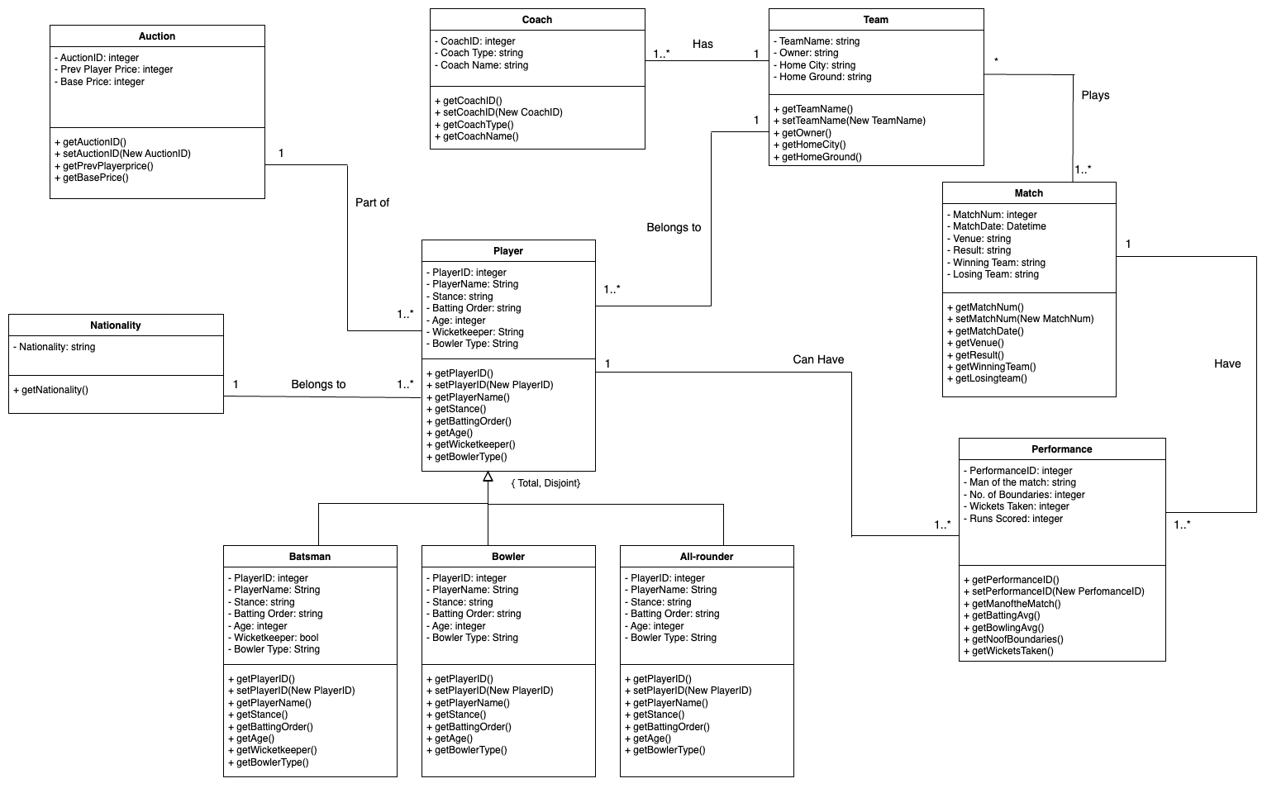

**RELATIONAL MODEL**

**Player** (Player ID, Player Name, Age, Stance, Batting Order, Wicketkeeper, Bowler Type*, Auction ID, Team Name*)

**Primary Key** – Player ID

**Foreign Key** – Auction ID refers to primary key of Auction and is NOT NULL

Team Name refers to primary key of team and is NOT NULL

**Batsmen** (Player ID, Player Name, Age, Stance, Batting Order, Wicketkeeper, Bowler Type)

**Primary Key** – Player ID

**Bowler** (Player ID, Player Name, Age, Stance, Batting Order, Bowler Type)

**Primary Key** – Player ID

**All Rounder** (Player ID, Player Name, Age, Stance, Batting Order, Bowler Type)

**Primary Key** – Player ID

**Nationality** (Player ID, Nationality Type)

**Auction** (Auction ID, Prev Year Price, Base Price, *Player ID*)

Primary Key – Auction ID

**Foreign Key** – Player ID refers to primary key of Player and is NOT NULL

**Coach** (Coach ID, Coach Name, Coach Type, *Team Name*)

Primary Key – Coach ID

**Foreign Key** – Team Name refers to primary key of Team

**Team** (Team Name, Owner, Home City, Home Ground )

**Primary Key** – Team Name

**Match** (Match Num, Match Date, Winning Team, Losing Team, Venue, Result)

**Primary Key** – Match Num

**Plays** (*Team Name, Match Num*)

**Primary Key** – Team Name and Match Num together make the primary key for plays

**Foreign Key** – Team Name refers to primary key of Team and NULL is allowed

Match Num refers to primary key of Match and is NOT NULL

**Performance** (Performance ID, No. of Boundaries, Runs Scored, Man of the match, Wickets Taken, *Player ID*, *Match Num*)

**Primary Key** – Performance ID

**Foreign Key** – Player ID refers to primary key of Player and is NOT NULL

Match Num refers to primary key of Match and is NOT NULL

SQL QUERIES

**CREATE STATEMENTS**

**Players Table:**

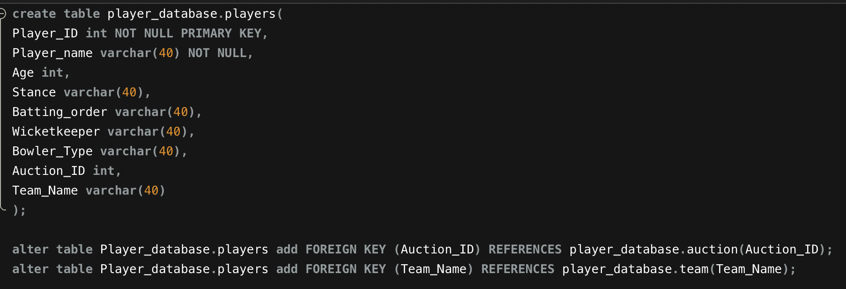

**Batsmen Table:**

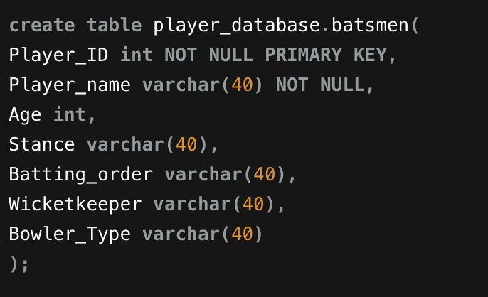

**Bowler Table:**

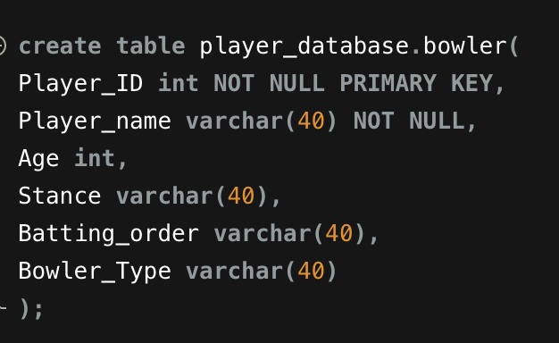

**All-rounder Table:**

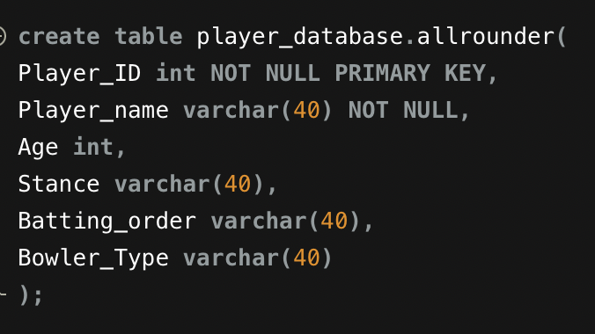

**Nationalities Table:**

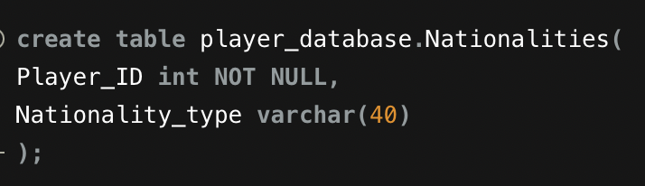

**Auction Table:**

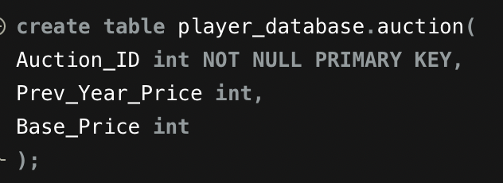

**Coach Table:**

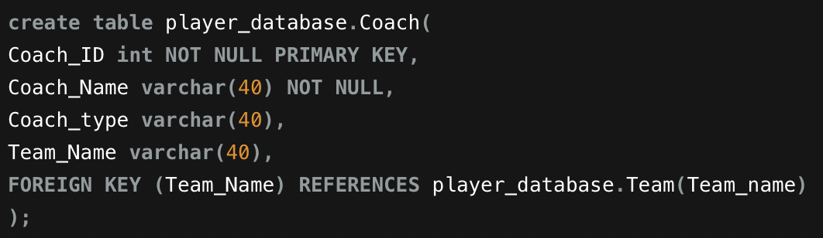

**Team Table:**

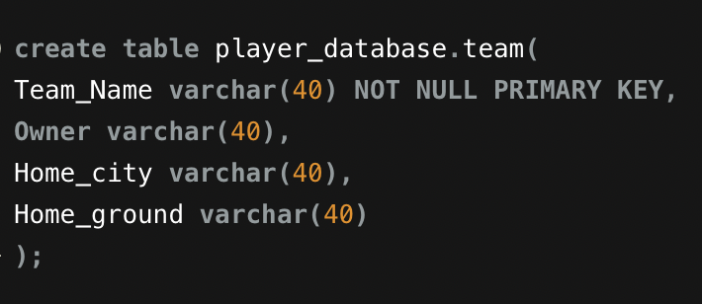

**Matches Table:**

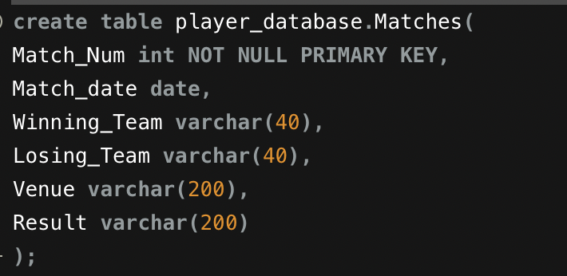

**Plays Table:**

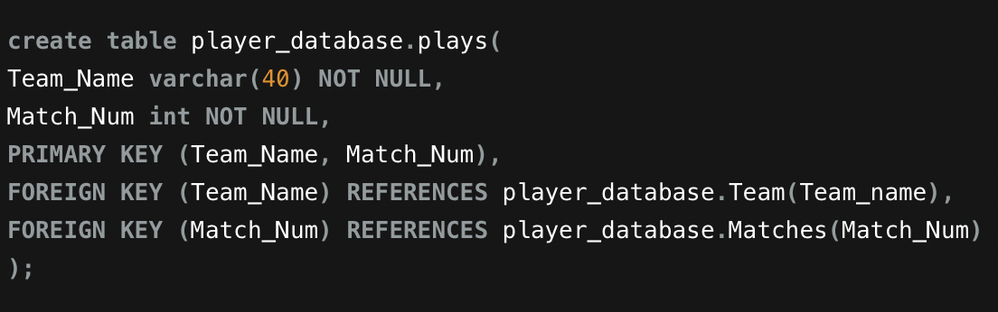

**Performances Table:**

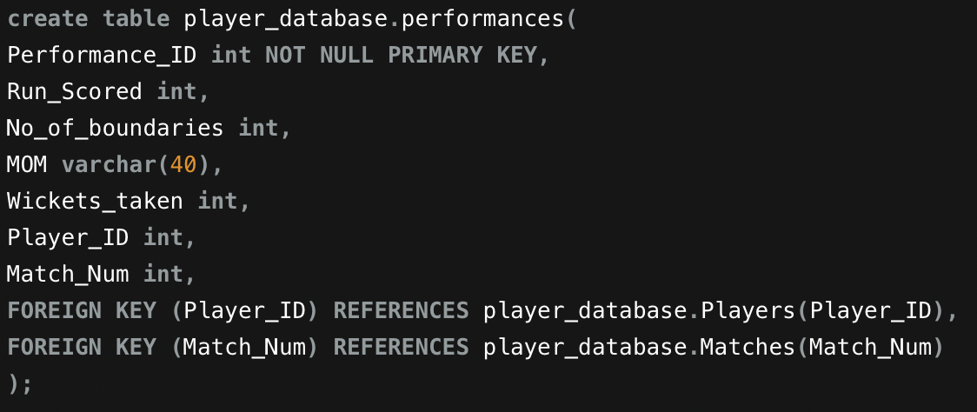

**INSERT STATEMENTS**

The Data was insert into the tables in two ways:

1. CSV file
2. Insert statements.

Depending on the requirements the data was inserted into the tables using either of the ways. Some of the sample insert statements are as follows:

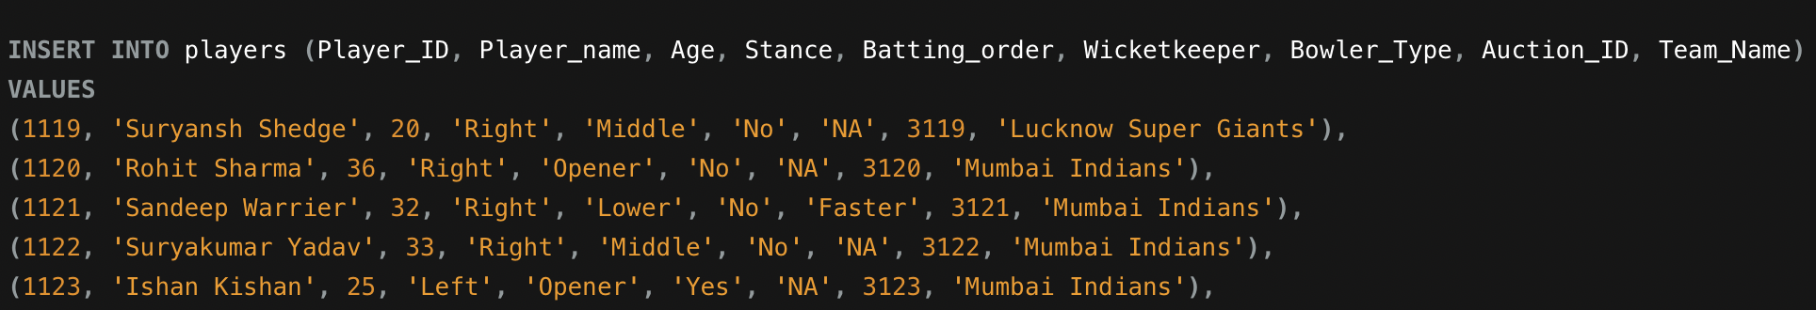

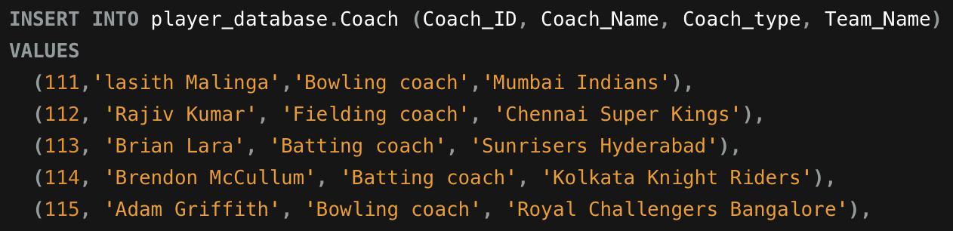



**ANALYTICAL QUERIES**

These queries will be used in the analysis of the data. These are:

